WA-WA PROJECT MEN’S HEALTH TRAINING REPORT.
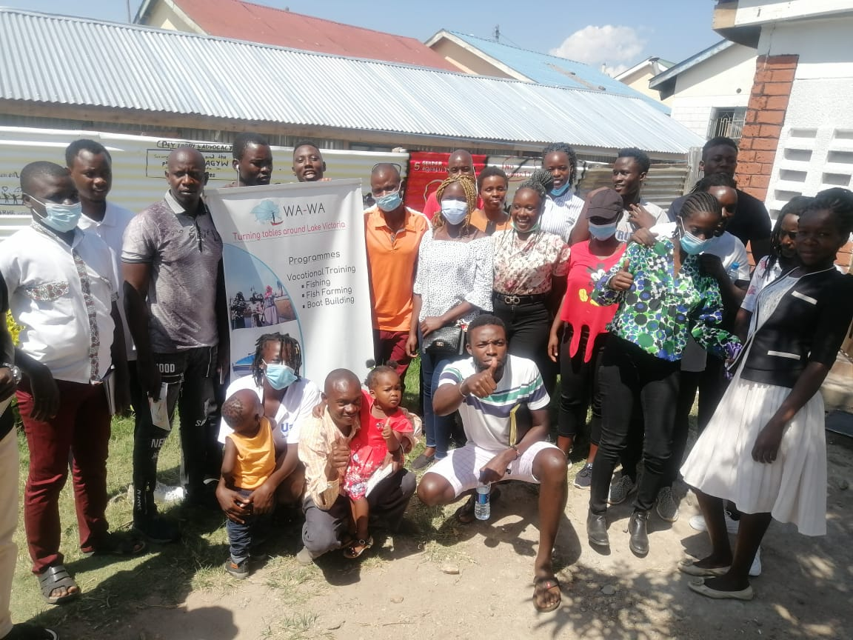Fig.1 group photo of community Men’s health facilitators
EXECUTIVE SUMMARY
Wa-Wa is a youth-led and Women- serving organization that embraces the rights-based approach to its programming and promotes women initiative that is dedicated to empowering women to participate equally in the management of their lives and that of the community. As part of its mandate of a healthy society, the project convened Men's health training under the support of making more health to mobilized community volunteers

This Men’s health training was a three-day event with participants drawn from Ndhiwa and Rachuonyo Sub County on 12th, 19th and 26th August 2021. Reaching a total of (Men 17 and 7 women) participants. The forums provided a platform for the community volunteers with the opportunity to learn more insight on mental health issues, Negative masculinity.

The forums also empowered the community Volunteers in reflection and in analysing societal norms, values and practices and how these affect the realization of the Men’s health. During the three-day forum, participants raised issues that need to be tackled. The numerous challenges to the achievement of the Health services in related mental health various interventions were explored and discussed as well. Other issues discussed included, practical and step towards eradicating systemic Negative masculinity, Steps towards the realization of alcohol and drug-free society. Solutions were offered and these are to be followed up and reviewed by end of September 2021.
This report, therefore, explores all the issues discussed and presents practical and concise steps to be taken.

INTRODUCTION
Wa-Wa through technical and financial support from making more healthy and community volunteer from Activate action and the Community. The Alliance convened a three-day Men health training at Sub County of Homa Bay Kenya. This was in consultation with our friend Harriet from making more health who has been handy throughout the process ensuring the following able facilitators engaged us.
Day 1. | Day 2. | Day 3.
Harriet | Harriet | Mike
Peter | Cavin | Bastian Franzmann
Cavin |  | Harriet and Cavin
The purpose was to create and strengthen linkages between Wa-Wa Kenya and Making more health
to ensure the Wa-Wa programme will be an able advocate for accessible, available, and acceptable mental health services, Non-discriminative Gender norms and shift from Existing behaviour to desired behaviour when it comes to alcohol and drug use.
It's envisaged that trained community volunteers will work in the community to uncover various gaps regarding the three training areas.
The training sought to achieve the following;
- To amplify Men's Health issues as a public health concern.
- To increase the mental health of men so that they can live fuller and happier lives.
- To significantly reduce the life risk and addictions that afflict men.
- To advocate for the government of Kenya involvement in men's health activities so that existing government health networks can be utilized to increase the health and well-being of men
The training in Homa Bay County was held on the following Dates.
Date | Venue | Training line
12th August 2021. | Homabay | Negative masculinity.
19th August 2021. | Homabay | Mental health
26th August 2021 | Homabay | Alcohol and drug

The training engaged diverse participants including; youth representatives from the local, religious leaders, CBOs; and special interest groups. They were engaged in conversations incorporating
Question and answer, case studies and experience sharing. This kind of engagement proved useful in
Empowering the facilitators to play active roles in efforts towards the realization of effective engagement with the community. This allowed them to share their ideas and opinions with facilitators from Making more Health which got equal attention regardless of age, gender, socio-economic status and educational level.
DAY ONE: Negative masculinity.
Introduction and welcoming remarks.
Cavin Odera Wa- Wa project Director welcomed the participants and led in self-introductions. He also led the group in stating their expectations for the training which were summarized as follows;
- To know more about Wa-Wa
- To learn more about male health and masculinity.
- To Positive masculinity to rank as high as feminism.
- Enjoy session.
- Understand why men are not able to share their problems.
The director Wa-Wa took the participant through the agenda and subsequently link the session to Harriet and Peter. Who introduced the training agenda taking them through the negative masculinity concept and how it affects people the community. Number scenarios were presented giving example
(i)Negative masculinity expression
-Paying a woman for laundry services and general house cleaning.
-A male refusing to receive services from a fellow male for example in a salon and spa.
-Not cooking when the sister and mother are around.
-Difficulty in expressing emotions for example after a heartbreak or loss of a loved one.
(ii)What do you see as the effects of negative expressions of masculinity?
-Poverty => not accepting to be employed in organisations led by women not accepting help from their partners.
-GBV_{s}=> physical assault, sexual assault.
-Divorce.
-Mental illness => shying away from sharing problems.
-Alcoholism and drug addiction.
(iii)What healthy expressions.
Further, participants were exposed to desired healthy expression as; Bravery, Protection, Opening up, Strength

To attain a deeper understanding of this issue, participants were taken through social institutions that promote this behaviour as; media school, religions, family and peers influence social constructs. This discussion was followed by a breakaway session highlighting the following.
Group work.1
Cultural taboos amongst the communities as a factor
- Women inheritance after the husband's death at some points one/two year period allowed for the mourning period.
- Sexual relationships are disallowed amongst relatives or families.
- Firstborn allowed to marry before the younger brother.
- Incest is never allowed at all costs.
- No sex contact in your father’s bed.
- Suicides were never allowed.
- A lady who has started a menstruation period is not allowed in the mother's bedroom.
- A virgin lady was paid a large bride price.
- Murder was never allowed in the family setup.
GROUP 2
Men were not supported to carry pots on their heads.
Incest was condemned in society.
Men were not allowed to have their own homes without a wife.
Men with compounds were not allowed to sleep in their father’s houses.
Women were inherited after the death of husbands.
Men were not allowed to engage sexually when their wives gave birth.
GROUP 3
- A girl cannot construct a house in their home.
- A man was not supposed to cry. That was an indication of weakness.
- Wife inheritance by the husband’s brother.
- Only men took part in polygamy.
- When the wife dies a man sleeps in the house until he dreams of the wife, then he is none free.
- The elder son is the one allowed to build.
- The son of the younger brother cannot construct a house before the elder son to the elder brother.
- A woman must maintain her virginity till marriage which does not apply to men.
Response from Wa-Wa Director.
He, however, spoke passionately about cases of gender norms and their effects requesting facilitators to be good ambassadors and champions for men's health in the villages, He went further citing issues that facilitators identified as the excising behaviour that Wa-Wa exists to change.
With that, a participant for another group works to understand the following;
(i) Group 1 Negative masculinity found;

- Superiority complex.
- Gender-based violence.
- Rape in the family.
- Emotional violence (egocentric)
Group 2. Effects of negative masculinity;
- Financial violence
- Sexual violence

- Gender parity: women are never given opportunities
- Violence
- Divorce cases on the rise
- Suicide
- Mental health
- Low self-esteem in men

The way forward and recommendations
The participants agreed that the following issues need to follow up and action soonest possible but not
Later than one month after the training;
- More community outreaches should be conducted to sensitize the community with a focus to men on negative masculinity.
- Wa-Wa project should have a continual men's health programme for at least one year to change the behaviour
- Trained facilitators should conduct community outreach through community organized forums Supported by the Wa-Wa project.
- The facilitator should get more similar training to build their capacity for knowledge dissemination.
- Wa-Wa project to establish referrals and linkages to clients that may require further services.
- Wa-Wa project to continuously conduct support supervision to trained facilitators and feedback meetings.
- Wa-Wa project to provide IEC materials for continua’s information dissemination.
Closing remarks.
Training 1. Ended by Rogers participant thanked Wa-Wa for the good work they have been doing in enlightening people on their rights and also in helping women with capacity building initiatives. He urged the project to organize more forums to reach more people who could be suffering quietly. He requested the participants to join in information dissemination among friends and neighbours to help in achieving the best outcomes possible.

DAY TWO: Mental health 19th August 2021.
Introduction and welcoming remarks
Rogers and Cavin welcomed the participants. He then led in self-introductions and thereafter asked the participants to state their expectations for the dialogue meeting. These were summarized as follows;
- To understand something new on Mental health and treatment
- To know the Wa-Wa project better
- To learn more about Mental health
- To know how the community can join hands to eradicate mental health conditions in the sub-county.
- To know why Homa Bay is still leading in high mental health prevalence rates in the whole Sub- County and what the community can do to reverse the trend.
- To forge collective interventions.

Rogers further reviewed the agenda of the training encouraging participants to share ideas on matters affecting the realization of mental health and gave a brief background of the work the Wa-Wa does. He also provided brief details of the thematic programmes of Wa-Wa namely; Women and Girls economic empowerment, AGYW Sexual and reproductive health rights.
This was followed by facilitators taking participants through the meaning of mental health, myths and misconception associated with it, later mental illness; which participant understood to be; depression, anxiety this followed by; Signs of mental illness;

-isolation
-panic
-hack
-abuse of drugs $ alcohol
-poor hygiene

Note Most men who suffer in silence resort to alcohol and drug abuse.
DAY THREE: Discussion on Alcohol and Drug Abuse 26th August 2021.
Introduction and welcoming remarks
Cavin Odera, Wa-Wa director, welcomed the participants. He asked each of them to do self-introductions stating, one expectation they have as the training coming to an end. Some of the expectations from the participants were summarized as below;
- To gain more knowledge on how to counsel people affected by Alcohol and Drug Abuse
- To understand our role in Men’s health in the community
- To know how Wa-Wa can help the groups in being strong in grassroots advocate for Men’s health.
- To seek stronger partnerships and networking with Wa-Wa and Making more health to improve mental health services to the people.
Wa-Wa director further took the participants through recap and the last topic Agenda. He emphasized the training is going to help a number of the people affected by mental health and realization of the Healthy society free from drug Abuse and alcoholism.
He stated the main purpose of the training was to allow the participants to share their experiences on Key issues and challenges that seem to affect the realization of men's health. This was followed by a reflection on alcohol and drug abuse, questions and answers sessions by participants through (12 multi-choices answers, and various scenarios
The exercise enabled participants to learn and appreciate the need to avoid drugs, drink responsibly. Why? The addictions of the two destroy marriages, friendships, and careers and threaten a person’s basic health and safety.
This is followed by training on various skills and practices drug and alcohol sensitization they need to have, Break and its importance.
In the end, Participant recommended;
- To have Drug and Alcohol sensitization activity in strict adherence covid-19 through organize forums in the community
- We have engaged partners- CBOs, youth groups who through their expertise will help to sensitize and create awareness in alcohol-drug abuse addiction.
- Each community volunteers to organized an activity that is to be supported by Wa-Wa and making more health
- Community volunteers to be provided with IEC materials for conducting community outreach.
- Wa-Wa project to communicate if it can provide refreshment and transport to community volunteers during community outreach
- Be provided with identification marks ie t-shirt, Tags to support their work
- To have a monthly individual work plan and feedback meetings supported by the Wa-Wa project
This culminated in making a group work plan that will be used during follow-ups. It was agreed by the participants that the issues raised needs urgent action and that all these should be reported back in one month i.e. by October on what has been done.
The training beneficiaries were happy to report having gained skills appreciating facilitators who trained them with a lot of zeal
Closing remarks,
Erick Oyuga on behalf of the participant thanked Wa-Wa and Making more health for having organized and sponsored the training for the community. He hailed the work of Cavin Odera who has been very vocal when it comes to telling the community to change some behaviours and norms that are not healthy or useful for the development of the community. He urged Wa-WA to create more networks with other CBOs and NGOs to ensure the call for change is much louder so that minimizing mental health rights can be realized by everyone irrespective of their social, economic or political status.

ANNEXES
Participant list. Photos sample of pre and post evaluation forms.

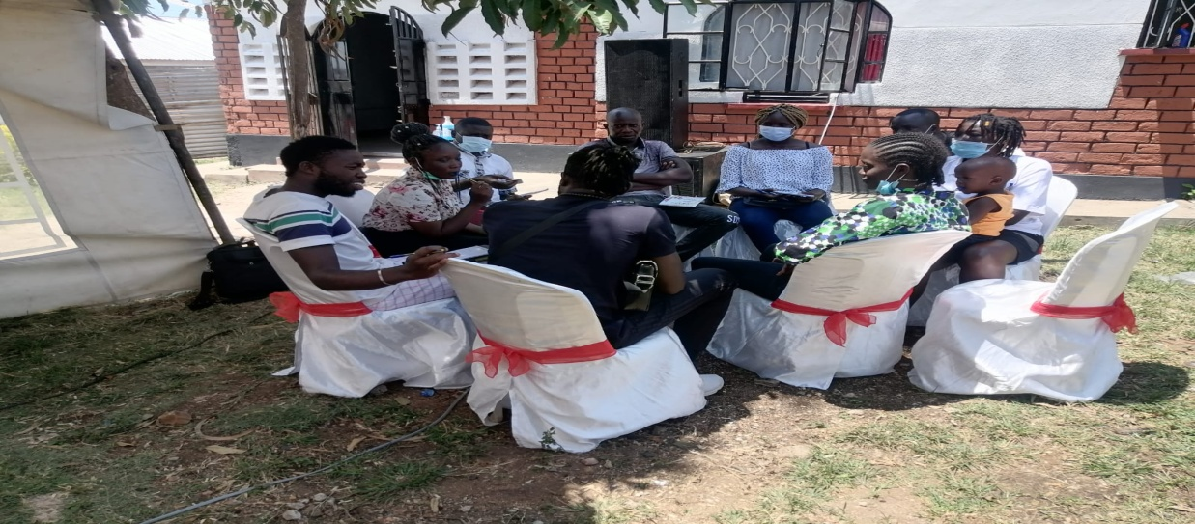
Fig .2 Focus group discussion during the training.

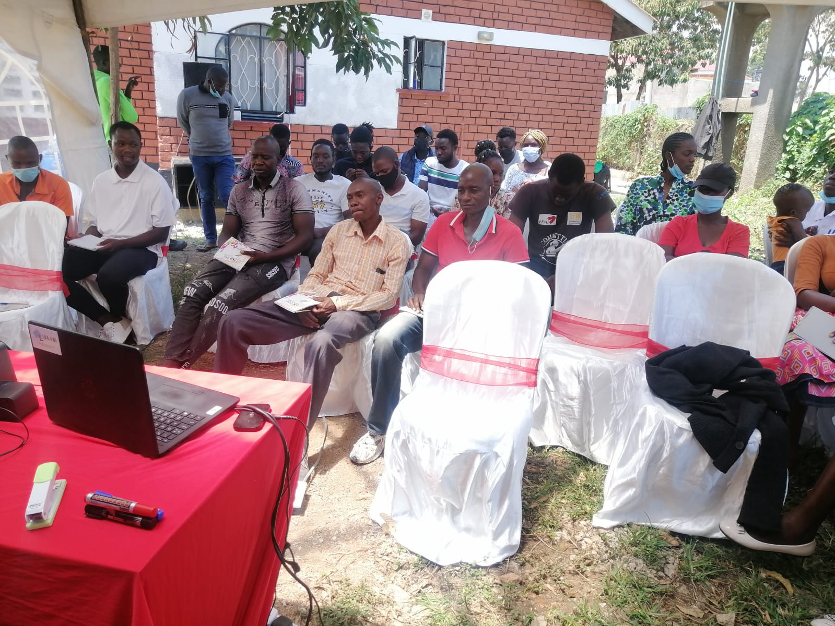
Fig.3.Community facilitators are being trained through zoom presiding.

